In the effort to make this event Net Zero we will not be providing name badges on the day, if you do wish to have a name badge we have sent this document so you can make your own prior to attending.

The badge once cut out will fit into any horizontal badge lanyard that fits a 90x60mm badge.

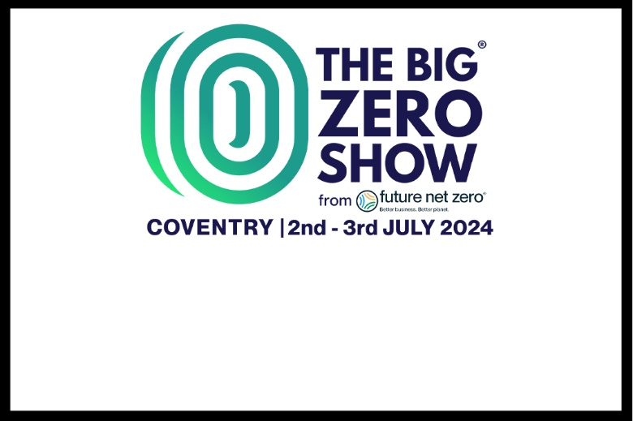

First & Last Name

Company